Artificial Intelligence

Experiment 3: Water Jug Problem

Name : J. Anisha Jenifer
Reg no : 192511004

Aim: Measure required water using two jugs

Algorithm
1. Initialize jugs.
2. Fill/empty/pour.
3. Repeat until goal.
4. Print steps.

Pseudo Code
Start
Fill/Pour/Empty
Repeat until target
Stop

Python Program
from collections import deque
def waterjug(a,b,target):
q=deque([(0,0)])
vis={(0,0)}
while q:
x,y=q.popleft()
if x==target or y==target:
print(x,y);return
nxt=[(a,y),(x,b),(0,y),(x,0),(max(0,x-(b-y)),min(b,x+y)),
(min(a,x+y),max(0,y-(a-x)))]
for s in nxt:
if s not in vis:
vis.add(s);q.append(s)
waterjug(4,3,2)

Input
Jug1=4 Jug2=3 Target=2

Output
2 3

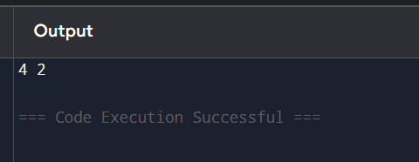

Experiment 4: Crypt-Arithmetic Problem

Aim: Solve SEND+MORE=MONEY.

Algorithm
1. Assign digits.
2. Check uniqueness.
3. Verify equation
4. Print solution.

Pseudo Code
Start
Assign digits
Check equation
Print solution
Stop
Python Program
from itertools import permutations

letters = "SENDMORY"
for p in permutations("0123456789", 8):
d = dict(zip(letters, map(int, p)))
if d['S'] == 0 or d['M'] == 0:
continue
send = 1000 * d['S'] + 100 * d['E'] + 10 * d['N'] + d['D']
more = 1000 * d['M'] + 100 * d['O'] + 10 * d['R'] + d['E']
money = 10000 * d['M'] + 1000 * d['O'] + 100 * d['N'] + 10 * d['E'] + d['Y']

if send + more == money:
print("SEND =", send)
print("MORE =", more)
print("MONEY =", money)
breakInput

Output
9567 1085 10652

